**OREGON INSTITUTE OF TECHNOLOGY**

**Computer Systems Engineering Technology Department**

***CST 315 – Embedded Sensor Interfacing I/O***

**Lab 6 – Transistor and MOSFET Switching**

**Chris Thomas**

**PURPOSE:**

The purpose of this lab is to apply NPN transistors and p-channel enhancement MOSFETs as solid state switches. The difference between Low and High Side Switching will be demonstrated.

**EQUIPMENT AND SUPPLIES:**

* RPi Pico with USB cable
* DMM with probes
* 1 – Power Supply capable of supplying 12VDC
* 1 – diode 1N4007
* 1 – 330 Ohm resistor
* 1 – 1.0K resistor
* 1 –2N3904 NPN Transistor
* 1 – TP2104N p-channel enhancement MOSFET
* 1- 12Volt Relay
* 1- water pump with 12V motor
* 1- push button switch
* wire

**Part 1**

1. Build the circuit in the Low Side Switching Circuit Schematic. In this circuit the RPi Pico will turn a relay (DPDT) on and off. The pinout for the transistor is given at the end of the lab handout. The relay is an electromechanical switch capable of controlling both DC and AC powered devices (within the relays spec limitations). This circuit is referred to as Low Side Switching because the switch (the transistor in this case) is between the device being controlled (the relay) and the “low side” (ground) of the circuit. Be careful with the 12V power supply. The positive terminal of the supply is connected to the relay. The ground of the 12V supply is connected to the to the ground of the circuit. Also note the orientation of D1 remembering that the cathode side of the diode is marked with a silver band. Ask if not sure.
2. Load the Micro Python code (listed at the end of the lab handout) into the Pico. The code will produce a 3.3V output from GP14 (physical pin 19) when the button (S1) is pressed. That control voltage will turn on the relay by producing a base current in the transistor which produces a large enough collector current to activate the relay. You should hear a small click and see the armature of the relay move. Releasing the button will produce a 0V signal which will kill the base current thereby reducing the collector current to zero and deactivating the relay.
3. With the button pressed (S1) measure the following:
4. The base current (Ib)____6.35mA_____
5. The collector current (Ic) ___82mA_____
6. The collector to emitter voltage (Vce) ____170mV_____
7. Calculate βDC by dividing Ic by Ib ____12.9______
8. Do you know why D1 is in the circuit?

To protect from voltage spikes.

**PART 2**

1. Construct the circuit shown in the High Side Switching schematic. This circuit is referred to as a “High Side Switching Circuit” because the switch (the MOSFET) is between the “High Side” or the positive terminal of the power supply and the device being powered (the water pump). Ignore the diode symbol inside of the MOSFET symbol. It is indicating an internal or parasitic diode inside the MOSFET due to how the MOSFET is built.
2. Use the same code as in step 2 above. Pressing the button switch will cause the water pump to run. The Pico will produce a large enough base current to put the transistor into saturation as in Part 1. Recall that a transistor in saturation will have a very small collector to emitter volage (Vce) – approaching zero volts. The gate terminal of the MOSFET is tied to the collector terminal of the transistor. To turn on a p-channel MOSFET the voltage between the gate terminal of the MOSFET must be more negative than the source terminal. For our MOSFET the gate must be at least 2 volts more negative than the source for the MOSFET to start to conduct. The source terminal of the MOSFET is connected to the positive side of the 12 V supply. When the transistor goes into saturation the voltage at the gate of the MOSFET drops to about 1 or 2 volts (since it is tied to the transistor’s collector). The gate will be about 10 or 11 volts more negative than the source so the MOSFET will turn on.
3. With the push button pressed measure:
4. the voltage between the gate and source terminals of the MOSFET__-11.97V
5. the motor current ___190mA_______

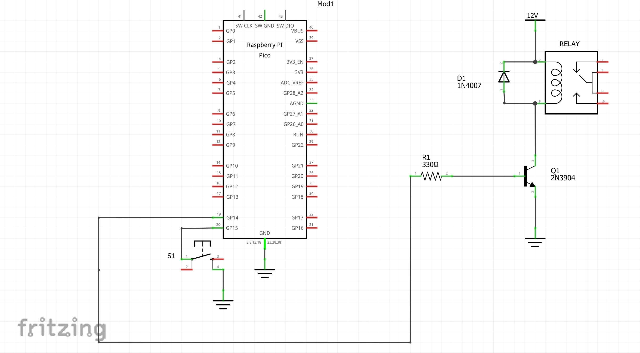

**Low Side Switching Schematic**

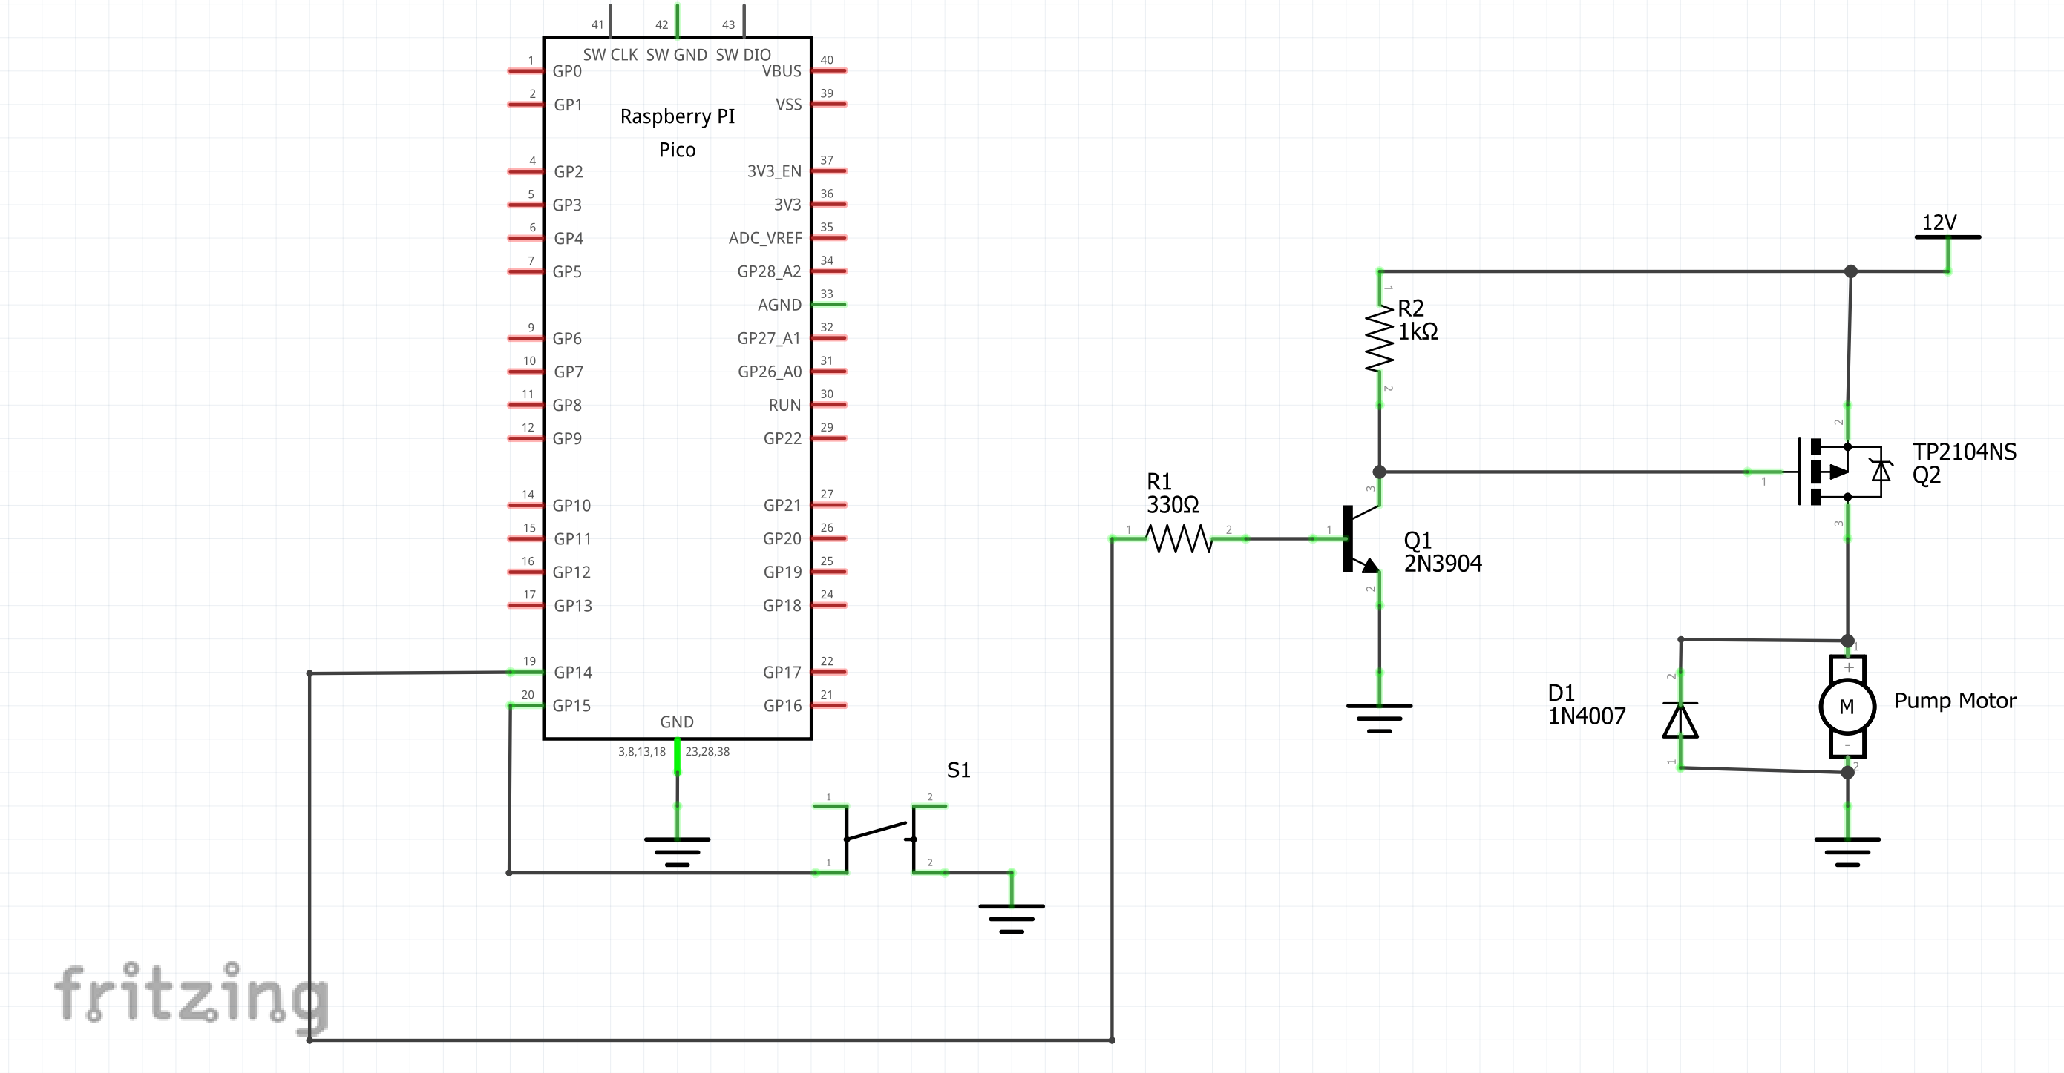

**High Side Switching Schematic**

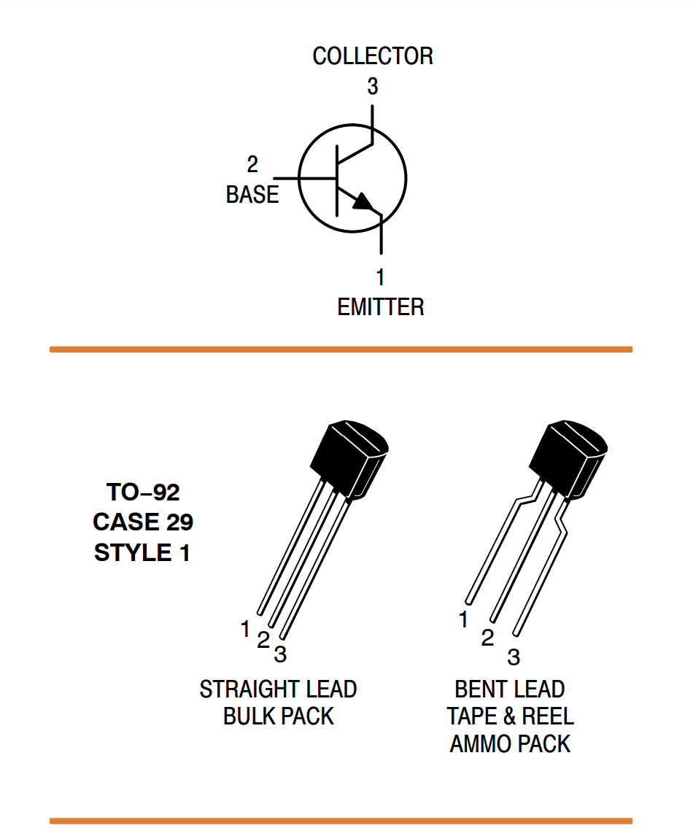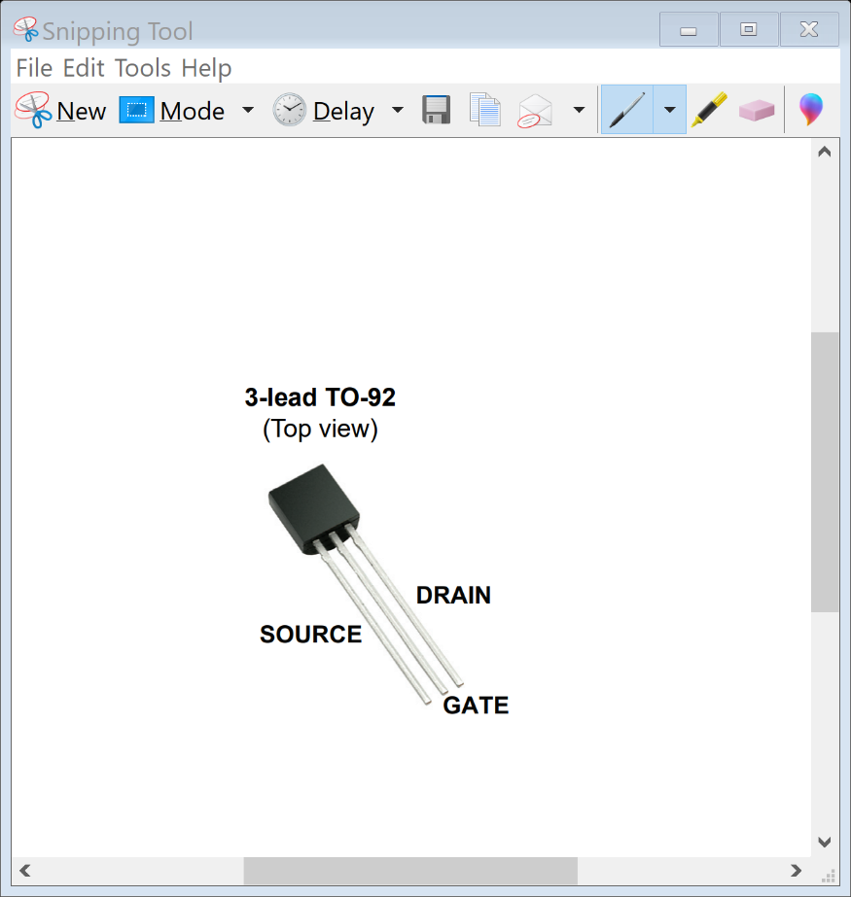

**2N3904 NPN Transistor Pinout TP2104N p-channel enhancement MOSFET**

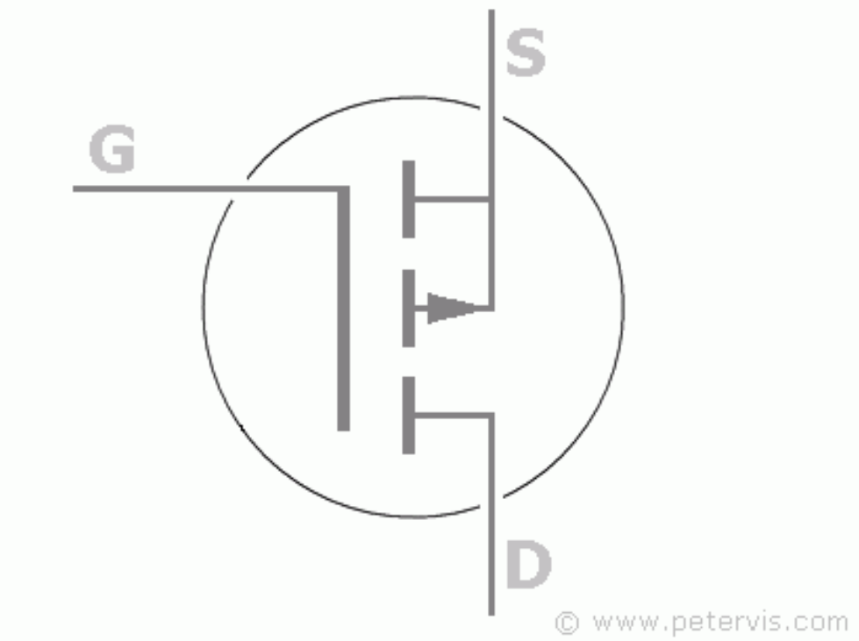

**Schematic Symbol for p-channel enhancement MOSFET**

**Micro Python Code for Lab 6**

**import machine**

**import utime**

**led_onboard = machine.Pin(25, machine.Pin.OUT)**

**motor = machine.Pin(14, machine.Pin.OUT)**

**button = machine.Pin(15, machine.Pin.IN, machine.Pin.PULL_UP)**

**while (button.value() == 1):#Loop here if button not pressed**

**utime.sleep(.1)#debounce**

**led_onboard.value(0)**

**motor.value(0)#turn motor off**

**while (button.value() == 0):**

**utime.sleep(.1)#debounce**

**led_onboard.value(1)**

**motor.value (1)**